Managing Your ECF Noticing Configuration
Introduction 1
Email Configuration 1

Introduction

All filings in the District of South Carolina are filed electronically. Filing users receive email notifications related to filings, as well as notices and announcements from the court. It is important that filing user information is accurate and current.

Email Configuration

NEFs will be sent to the filing user’s primary email account. Filing users can also add secondary email addresses to their account and these accounts will also receive NEFs.

If a filing user changes his/her primary email address, it is the filing user’s responsibility to update it on their PACER account. PACER will notify the court of this update.

To update or add secondary email addresses:

STEP | RESULT
Once logged into ECF, choose Utilities > Your Account > Maintain Your Email. | 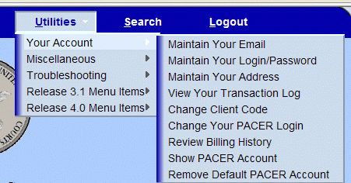

STEP | RESULT
Select a secondary email address to configure. | 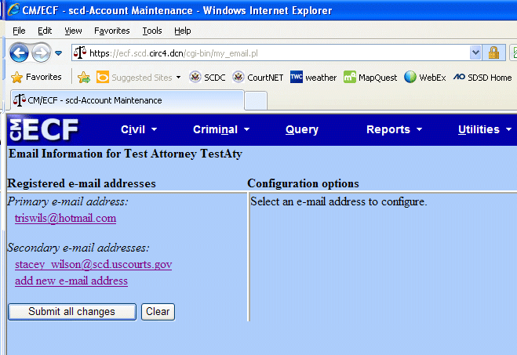
Enter/Verify Secondary e- mail addresses as appropriate.  Click add new e-mail addresses to add and configure additional addresses.  Respond to the questions.  NOTE: If you check “no” to the question about this e-mail address receiving notices, you will no longer receive NEFs.  Filing users receive notices in all of their cases. A filing user can identify and list here other cases in which they are interested.  NOTE: Once the email address is entered, the remainder of the screen with questions will appear. | 